EXPERIMENT NO. 6 / 7
UML Activity Diagram (Workflow Modeling)
Project: Hospital Management System (HMS)
Prepared by: Anish Chitnis (24CE1044) | Aaryan Choube (24CE1045) | Somansh Dafade (24CE1047)
Batch: A / A1 | Dept of Computer Engineering, RAIT, DY Patil University
1. Aim
To study and construct the UML Activity Diagram for the Hospital Management System (HMS), modeling dynamic workflows, decision branches, concurrent parallel execution (fork/join), and multi-actor swimlanes.
2. Objectives
• To model business workflows from patient check-in to consultation, diagnosis, medication, and final billing.
• To partition operational responsibilities using Swimlanes (Patient, Receptionist, Doctor, Diagnostic/Pharmacy, Billing System).
• To represent concurrency using Fork and Join synchronization bars.
• To model decision branching (slot availability, insurance applicability, payment retry logic).
3. Activity Diagram
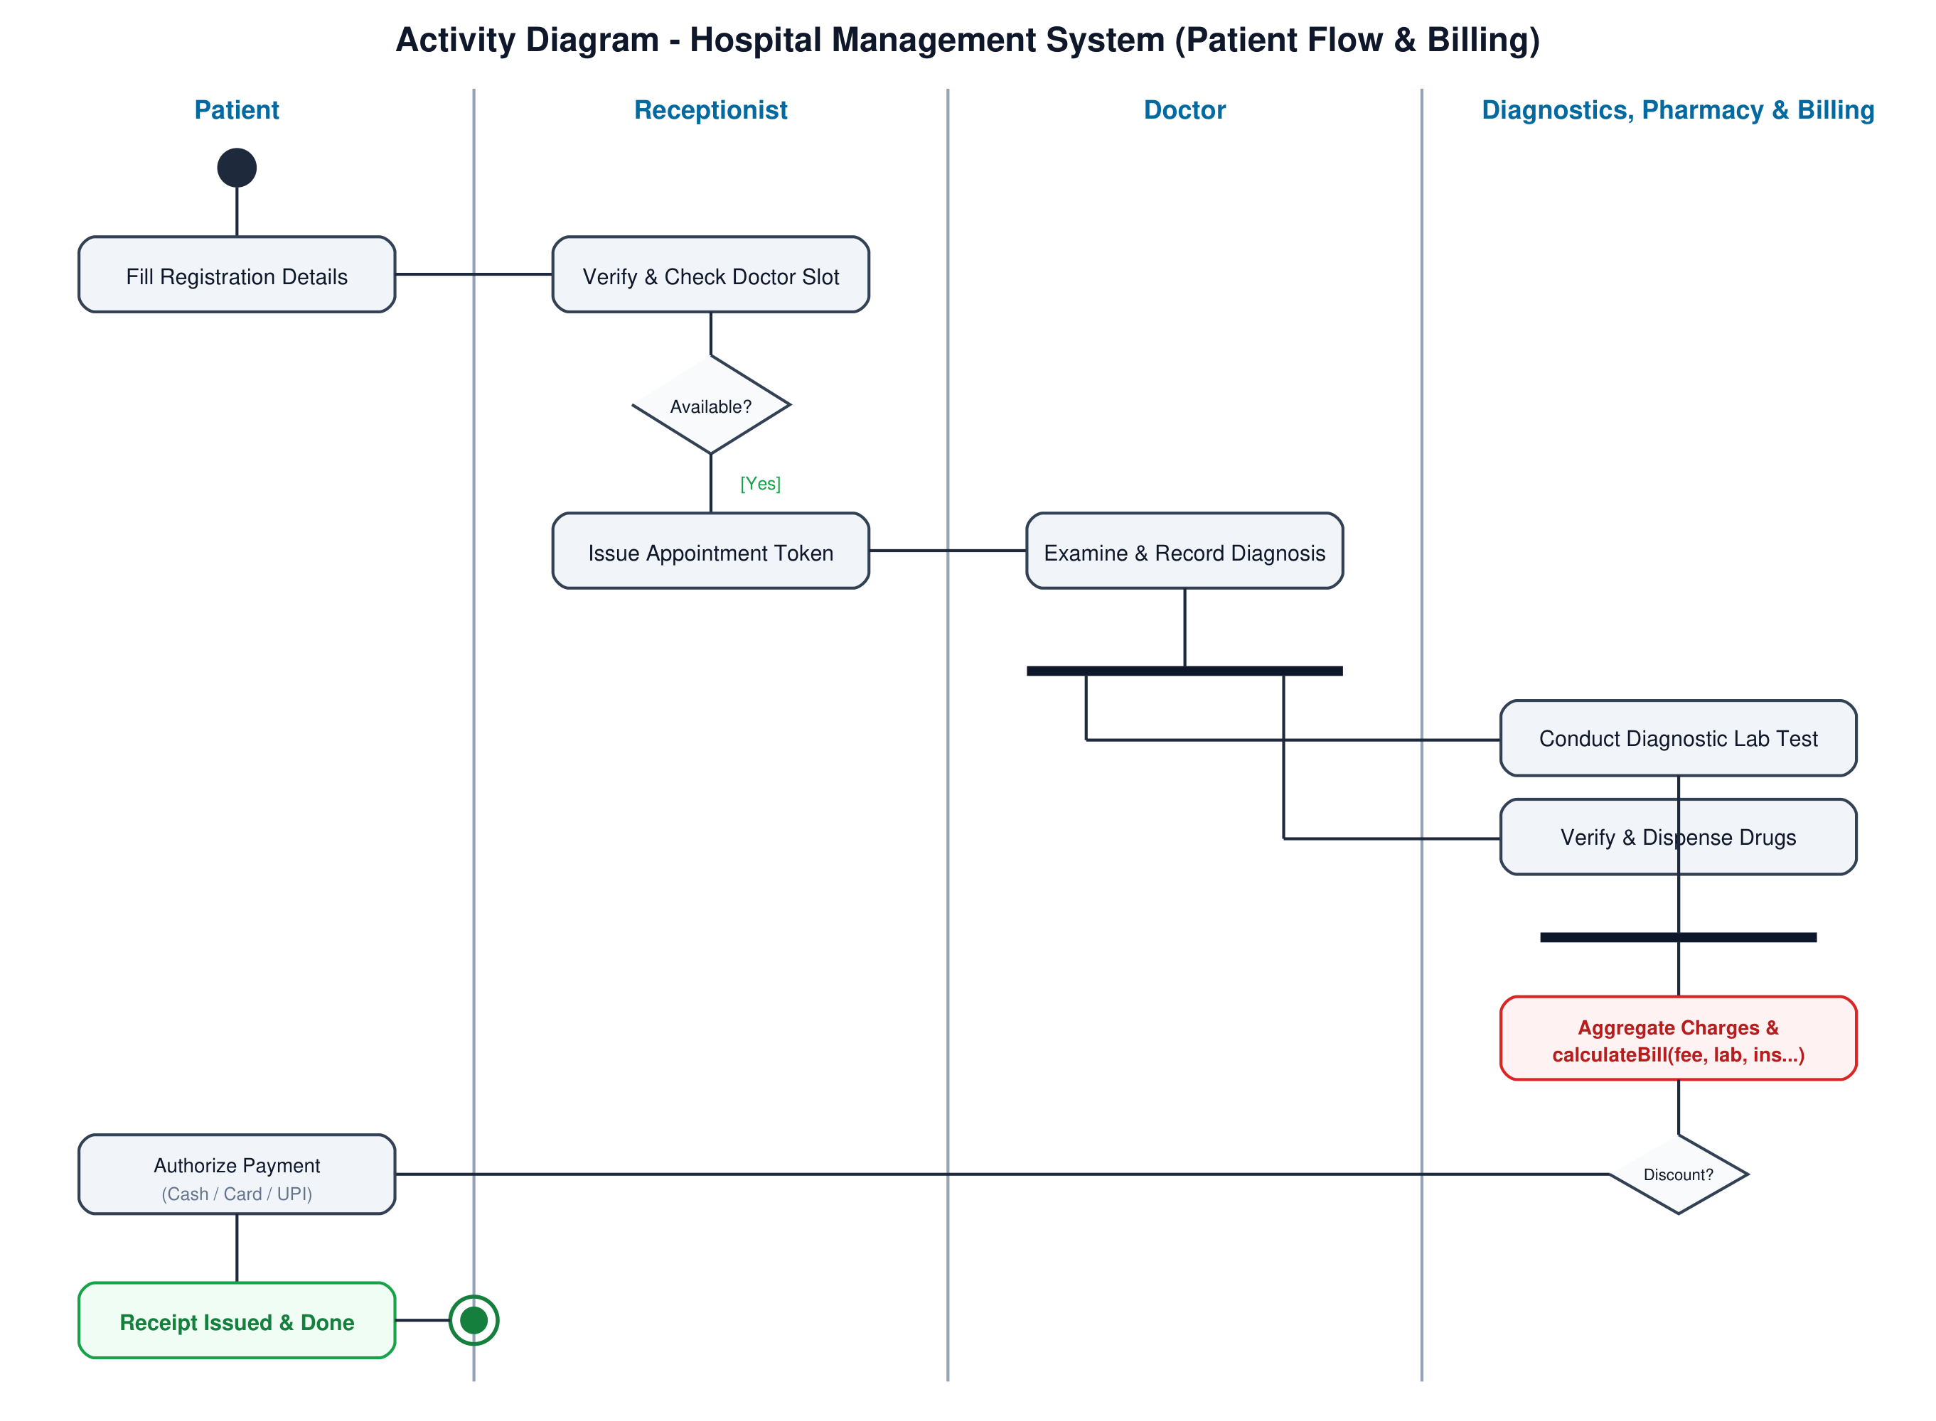
Fig 1: Activity Diagram - Patient Flow & Billing Workflow (HMS)
4. Workflow Documentation & Swimlanes
1. Patient Registration & Slot Check: Patient fills details; Receptionist checks doctor calendar. If slot available, token is issued; otherwise, alternate slot is negotiated or booking terminated.
2. Clinical Examination: Doctor examines patient and enters clinical findings in EHR.
3. Fork Bar (Concurrent Execution): The workflow forks into two parallel operational activities:
• Branch A: Diagnostic lab test ordered ➔ Specimen collected ➔ Analysis conducted & lab report uploaded.
• Branch B: Prescription issued ➔ Pharmacist verifies medicine stock ➔ Drugs dispensed.
4. Join Bar (Synchronization): Both lab reporting and drug dispensation synchronize before financial settlement.
5. Billing & Payment: calculateBill aggregates fees. If insurance is present, discount is applied. Patient authorizes payment. Upon success, digital receipt is issued and patient is discharged.
5. Conclusion
The Activity Diagram effectively captures the concurrency and decision logic inherent in hospital clinical operations, demonstrating clear accountability across departments.

